Importing Data from Excel to SSIS

Choose the Data Source File

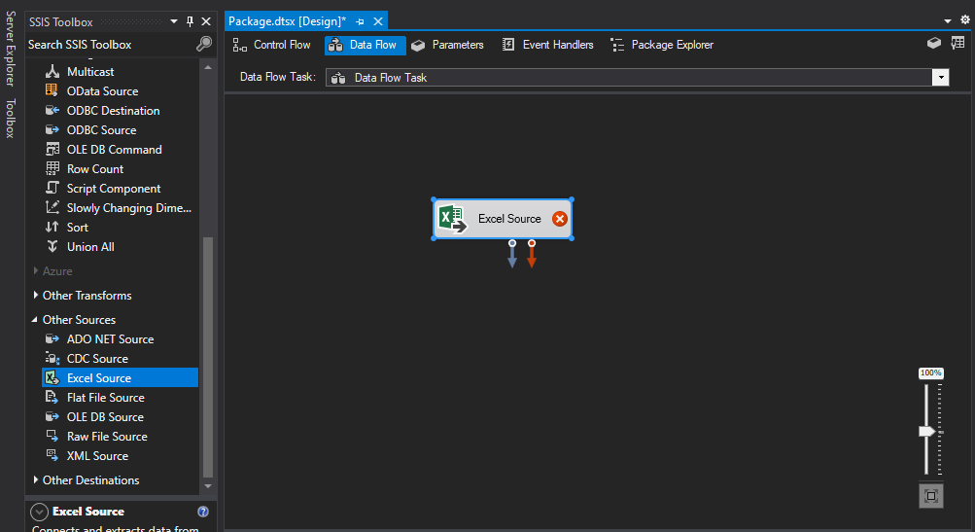

Now We Will Configure the Data Source File

Double Click on the Excel Source File and Pop-Up Window will Appear.

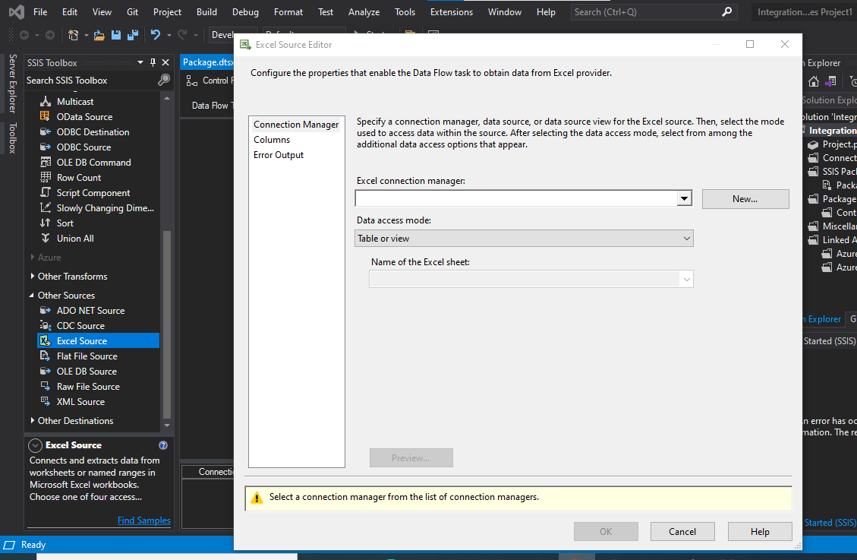

Click on the New and Configure the Connection with the Excel File that you want to import to Sql Server.

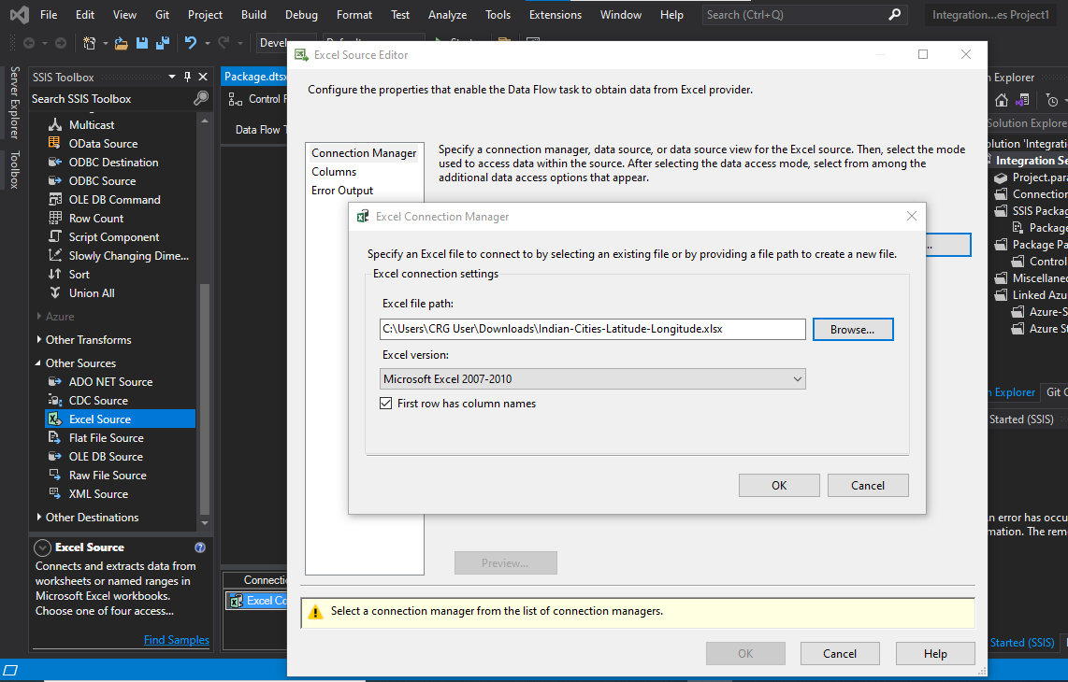

Connection with Excel File is Created.

Now We Need to Create a table in Sql in which we want to Store the data of Excel file.

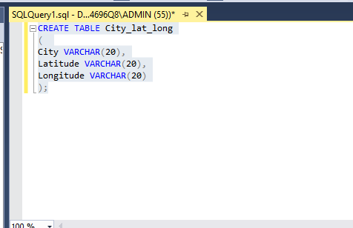

Now From Destination Source Choose **OLE DB SOURCES**

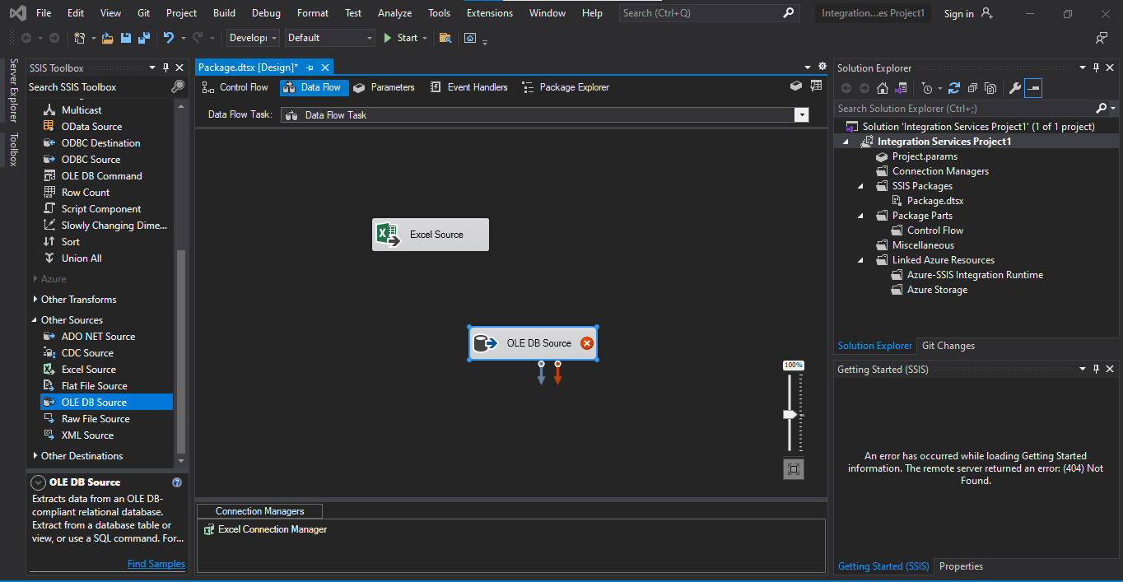

Now Configure OLE DB SOURCE Connection.

Double Click on **OLE DB SOURCE** Pop up window will appear Configure it.

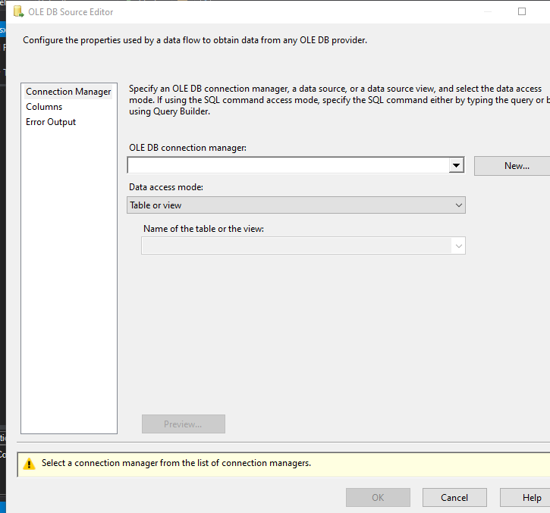

Click on New

Again, Click on New

Enter the Server Name of SQL

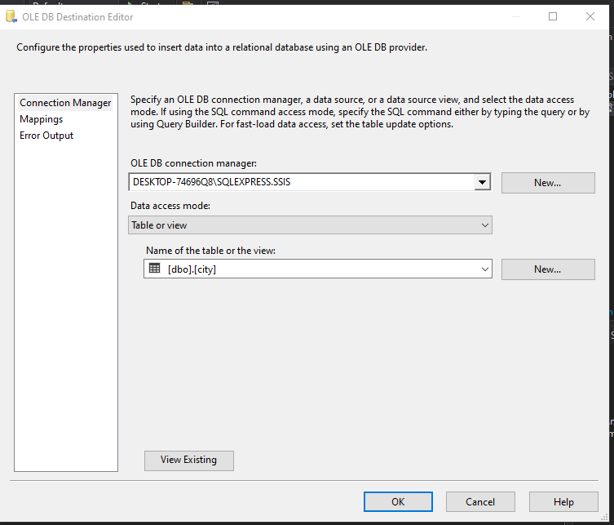

Map the Column Name With Excel file columns and sql columns

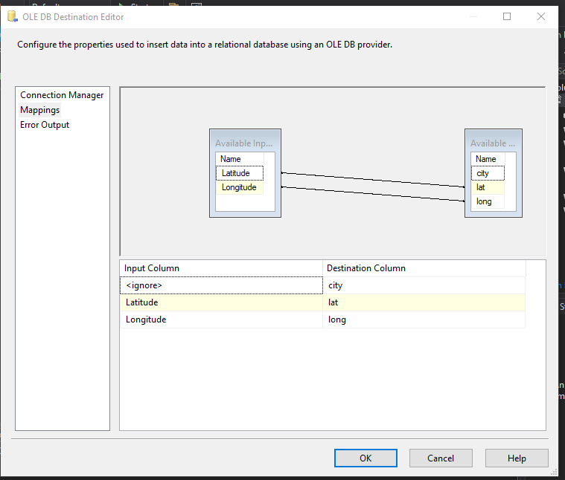

Now Configuration is Done

Start the Package and its Done